September 5, 2022
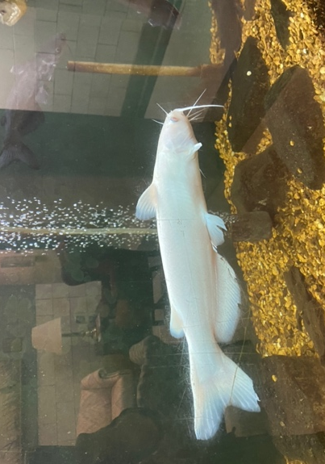
Experience Report: Mississippi State University Aquaculture Research and Diagnostic Lab
This albino catfish greets all visitors to the NWAC.

Dear AAFV Scholarship Committee,

Thank you so much for selecting me as one of the recipients of the 2022 AAFV Student Scholarship. Due to the generosity of this committee and the scholarship donors, I was able to complete a two-week externship at Mississippi State University College of Veterinary Medicine’s Aquaculture Research and Diagnostic Lab in Stoneville, Mississippi, in August 2022.

I chose to complete an externship at ARDL to learn more about health management of catfish, which are an important sector of the aquaculture industry in the United States, and to improve my skills in fish necropsy and diagnostic sampling. Under the guidance of Dr. Lester Khoo, I saw most of the major diseases of catfish including enteric septicemia of catfish, columnaris disease, atypical Aeromonas infection, and Edwarsiella piscicida infection. Dr. Khoo taught me how to identify these diseases, as well as channel catfish virus and visceral toxicosis of catfish, by gross lesions, cytology, microbiology, and histopathology. Through examination of gill wet mounts, I also gained proficiency in identifying freshwater parasites such as sessile ciliates, Trichodina, and Ichthyobodo.
Trichodina from the gill of a catfish.
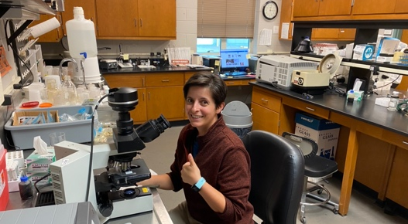
Once presumptive or definitive diagnoses were determined for a case, I was able to listen in while Dr. Khoo discussed treatment and management options with the farmers. During my time at ARDL, I read and learned a lot about the catfish industry and how it differs from other aquaculture sectors. Having just completed a salmonid externship in the Pacific Northwest, I was able to compare the decision-making process between the two industries. For example, due to the presence of local feed mills, medicated feeds are readily available in the Delta while it may take days to weeks to receive medicated feed in the Northwest. However, due to the large numbers of catfish in a single pond that may need to be treated, I learned that it is very important to consider alternatives to medicated feed both for antimicrobial stewardship and for the economic wellbeing of the farm.
Learning about histopathology.

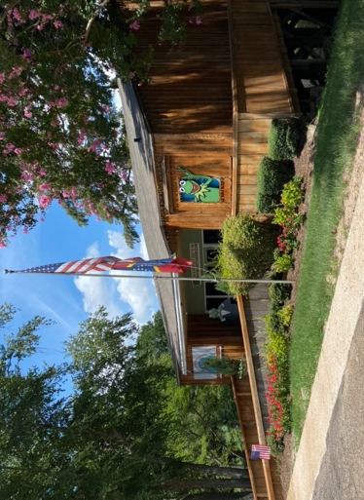
One unexpected benefit of my time at ARDL was the opportunity to improve my histopathology skills. Dr. Khoo has a large collection of slides that included a large variety of fish species, from catfish to seahorses. In between seeing cases, I was able to stumble through these slides while Dr. Khoo patiently helped me to improve my pattern recognition and understanding of pathogenesis of many fish diseases. Through these pathology mini-labs, I was able to see the histologic presentations of mycobacteriosis, lymphocystis, fungal and oomycete infections, goiter, and much more.
"Birthplace of Kermit the Frog" museum

Outside of the lab, I also got a chance to sample the local fare (specifically – catfish, pie, and pecans) and I was able to visit the “Birthplace of Kermit the Frog” museum in Leland. Altogether, this externship was a very valuable experience as I learned a lot about an important aquaculture industry, improved my fish pathology skills, and received quality mentorship from Dr. Khoo. I am very grateful to AAFV for funding my interest in fish medicine!

